**ECO 101**

**Theory of Demand**

It must be remembered that demand in Economics is always stated with reference to a particular price. Any change in price will normally bring about a change in the quantity demanded. In addition to price, demand is also used in reference to a particular period of time. For Example- demand for umbrellas will not be as high in winter as during rains. The demand for any commodity or service, therefore, must be stated with reference to the price and the relevant point of time.

We know that people have numerous wants which vary in intensity and quality. Just desiring or wanting things is not enough to create a demand. Suppose, a mill worker desires or wants to have a car but does not have the necessary means to buy it.

This desire is ineffective and will not become a demand. Similarly, a miser may desire to have the car, has means to purchase it, but will not spend the money. His desire would also not constitute a demand. Thus, we define demand for a commodity or service as an effective desire, i.e., a desire backed by means as well as willingness to pay for it.

The demand arises out of the following three things:

i. Desire or want of the commodity.

ii. Ability to pay,

iii. Willingness to pay.

Only when all these three things are present then the consumer presents his demand in the market.

Definitions:

“Demand for a commodity is the quantity which a consumer is willing to buy at a particular price at a particular time.”

“The demand for anything, at a given price, is the amount of it which will be bought per unit of time at that price.” -PROF. BENHAM

“By demand, we mean the quantity of a commodity that will be purchased at a particular price and not merely the desire of a thing.”-HANSEN

**Demand Function:**

Demand function shows the relationship between quantity demanded for a particular commodity and the factors influencing it. It can be either with respect to one consumer or to all the consumers in the market.

A consumer’s demand for a commodity is influenced by the following factors:

1. A consumer’s demand for a commodity is influenced by the price of that commodity. Usually the higher the price, the lower will be the quantity demanded.

2. A consumer’s demand for a commodity is influenced by the size of his income. In most cases, the larger the income, the greater will be the quantity demanded.

3. A consumer’s demand for a commodity is influenced by the prices of related commodities. They may be complementary or substitutes.

4. The tastes of the consumers.

In technical language, it is said that the demand for a commodity is a function of the four variables above and is written like:

q = f(P, Y, Pr, T)

Where q stands for quantity demanded, P stands for the price of the commodity in question, Y stands for the income of the consumer, Pr indicates prices of the related commodities and T denotes the Tastes of the consumer and f stands for function. But in practice the three of these four variables remain constant. And hence the demand function takes the form of-

q = f(P)

**Factors Determining Individual Demand:**

Demand is not dependent on price alone. There are many other factors which affect the demand of a product.

These factors are as follows:

1. Price of the Product:

Demand for a commodity depends on its price. As price rises, for a normal good, demand falls and vice-versa. However, there are exceptions, i.e., for Giffen goods, as price rises demand also rises.

2. Income of the Consumer:

A key determinant of demand is the level of income i.e., the higher the level of income the higher the demand for a given commodity. Consumer’s income and quantity demanded are generally related positively. It means that when income of the consumer rises he wants to have more units of that commodity and when his income falls he reduces the demand.

In consumer theory, an inferior good is a good that decreases in demand when consumer income rises i.e., increase in income reduces the demand because the consumer shifts his consumption to superior goods and forgoes his existing product. Thus reducing its demand.

Cheaper cars are examples of the inferior goods. Consumers will generally prefer cheaper cars when their income is constricted. As a consumer’s income increases the demand for cheap cars decreases and demand for costly cars increases.

3. Prices of Related Goods:

Consumption choices are also influenced by the alternative options available to users in the relevant market place. Market information regarding alternative products, quality, convenience and dependability all influence choices.

The two products may be related in two ways- Firstly, as complementary goods and secondly as substitute goods.

Complementary goods are those goods which are used jointly and consumed together like tennis ball and a racket, petrol and car. The relationship between the price of a product and the quantity demanded of another is inverse. For example if the price of cars were to rise, less people would choose to buy and use cars, switching perhaps to public transport-trains. It follows that under these circumstances the demand for the complementary good petrol would also decrease.

Goods which are perceived by the consumer to be alternatives to a product are termed as substitute goods. There is direct relationship between the demand for a product and the price of its substitute. Example- scooter and a motorcycle, tea and coffee.

The increase in price of tea would decrease its quantity demanded and people would switch over to its substitute commodity coffee.

4. Consumer’s Tastes and Preferences:

Demand for a product is also affected by the tastes and preferences of the consumers. As tastes and preferences shift from one commodity to the other, demand for the first commodity reduces and that of the other rises.

5. Expectation of Future Prices:

The current demand of a product also depends on its expected price in future. If future price is expected to rise, its present demand immediately increases because the consumer has a tendency to store it at low prices for his future consumption. If, however the price of a product is expected to fall then he has a tendency to postpone its consumption and as a result the present demand would also fall.

This is often the case on Budget Day, when consumers rush to fill their petrol tanks prior to an expected increase in taxation. The reverse is also true, in that an expectation that prices are about to fall, will decrease current demand, as consumers will await for the expected price reduction.

6. Economic Conditions:

The demand for commodities also depends upon prevailing business conditions in the country. For, example- during the inflationary period, more money is in circulation and people have more purchasing power. This causes an increase in demand of various goods even at higher prices. Similarly, during deflation (depression), the demand for various goods reduces in spite of lower prices because people do not have enough money to buy.

**Factors Determining Market Demand:**

Market demand for a commodity means the sum total of the demand of all individuals. Market demand depends, not only on the prices of the commodity and prices of related commodities but also on the number of factors.

These are:

1. Pattern of Income Distribution:

If National income is equitably distributed, there will be more demand and vice-versa. If income distribution moves in favour of down­trodden people, then demand for such commodities, which are used by common people would increase. On the other hand, if the major part of National income is concentrated in the hands of only some rich people, the demand for luxury goods will increase.

2. Demographic Structure:

Market demand is influenced by change in size and composition of population. Increase in population leads to more demand for all types of goods and decrease in population means less demand for them. Composition of population also affects its demand. Composition refers to the number of children, adults, males, females etc., in the population.

When the composition changes, for example, when the number of females exceeds to that of the males, then there will be more demand for goods required by women folk.

3. Government Policy:

Government policy of a country can also affect the demand for a particular commodity or commodities through taxation. Reduction in the taxes and duties will allow more persons to enter a particular market and thus raising the demand for a particular product.

4. Season and Weather:

Demands for commodities also depend upon the climate of an area and weather. In cold hilly areas woolens are demanded. During summer and rainy season demand for umbrellas may rise. In winter ice is not so much demanded.

5. State of Business:

The levels of demand in a market for different goods depend upon the business condition of the country. If the country is passing through boom, the trade is active and brisk. The demand for all commodities tends to rise. But in the days of depression, when trade is dull and slow, demand tends to fall.

**Demand Schedule:**

The demand schedule in economics is a table of quantity demanded of a good at different price levels. Given the price level, it is easy to determine the expected quantity demanded. This demand schedule can be graphed as a continuous demand curve on a chart where the Y-axis represents price and the X-axis represents the quantity.

According to PROF. ALFRED MARSHALL, “Demand schedule is a list of prices and quantities”. In other words, a tabular statement of price-quantity relationship between two variables is known as the demand schedule.

The demand schedule in the table represents different quantities of commodities that are purchased at different prices during a certain specified period (it can be a day or a week or a month).

The demand schedule can be classified into two categories:

1. Individual demand schedule;

2. Market demand schedule.

1. Individual Demand Schedule:

It represents the demand of an individual’ for a commodity at different prices at a particular time period. The adjoining table 7.1 shows a demand schedule for oranges on 7th July, 2009.

[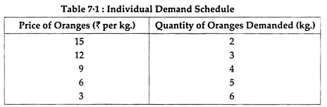](https://www.economicsdiscussion.net/wp-content/uploads/2018/07/clip_image002.png)

**2. Market Demand Schedule:**

Market Demand Schedule is defined as the quantities of a given commodity which all consumers will buy at all possible prices at given moment of time. In a market, there are several consumers, and each has a different liking, taste, preference and income. Every consumer has a different demand.

The market demand actually represents the demand of all the consumers combined together. When a particular commodity has several brands or types of commodities, the market demand schedule becomes very complicated because of various factors. However, for a single item, the market demand schedule is rather simple. Study the market demand schedule for milk in table 7.2.

[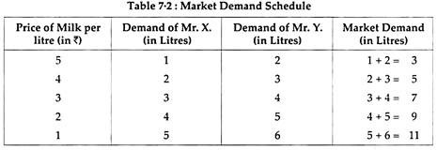](https://www.economicsdiscussion.net/wp-content/uploads/2018/07/clip_image004-2.jpg)

**Demand Curves (Diagram):**

The demand curve is a graphic statement or presentation of the relationship between product price and the quantity of the product demanded. It is drawn with price on the vertical axis of the graph and quantity demanded on the horizontal axis.

Demand curve does not tell us the price. It only tells us how much quantity of goods would be purchased by the consumer at various possible prices.

Depending upon the demand schedule, the demand curve can be as follows:

1. Individual Demand Curve

2. Market Demand Curve

1. Individual Demand Curve:

An Individual Demand Curve is a graphical representation of the quantities of a commodity that an individual (a particular consumer) stands ready to take off the market at a given period of time at different prices. In Fig. 7.1, an Individual Demand Curve is drawn on the basis of Individual Demand Schedule given above in table 7.1.

[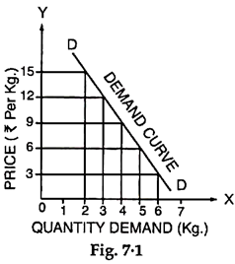](https://www.economicsdiscussion.net/wp-content/uploads/2018/07/clip_image006-1.png)

2. Market Demand Curve:

A Market Demand Curve is a graphical representation of the quantities of a commodity which all the buyers in the market stand ready to take off at all possible prices at a given period of time. In Figure 7.2 a Market Demand Curve is drawn on the basis of Market Demand Schedule given in Table 7.2.

[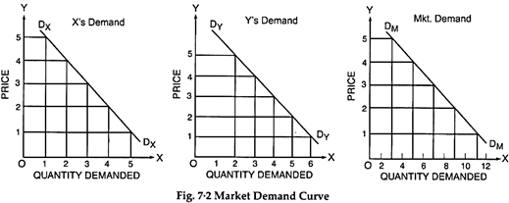](https://www.economicsdiscussion.net/wp-content/uploads/2018/07/clip_image007.png)

Both, the individual consumer’s demand curve is a straight line. A demand curve will slope downward to the right.

It is not necessary, that the demand curve is a straight line. A demand curve may be a convex curve or a concave curve. It may take any shape provided it is negatively sloped.

[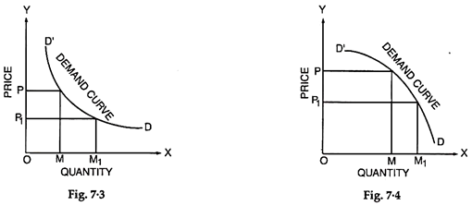](https://www.economicsdiscussion.net/wp-content/uploads/2018/07/clip_image008.png)

**Law of Demand:**

The law of demand expresses functional relationship between price and the quantity. It has been universally observed that people buy more quantity of goods when, they are available at a lower price and the quantity purchased declines with an increase in its price.

“A rise in the price of a commodity or service is followed by a fall in quantity demanded, and a fall in price is followed by an increase in quantity demanded”. Thus, lower the price, the larger is the quantity demanded of a commodity and vice-versa.

The law thus, states that other things being equal the quantity demanded varies inversely with price. Lower the price, greater is the effective demand; higher the price; lesser is the effective demand.

**Characteristics of Law of Demand:**

The law of demand has three specific characteristics:

1. General Tendency,

2. Relation to Time, and

3. Price and Demand Relationship.

1. General Tendency:

The law simply indicates a general tendency of changes in quantity demanded with the changes in prices. However, it does not mention any specific propositions of changes in quantity demanded with changes in prices.

2. Relation to Time:

The law of demand is always related to time, because the price changes from time to time and these are never fixed. Thus, the co-relation between the prices and the quantities demanded should be considered for a specific time or at particular instant.

3. Price and Demand Relationship:

The increase or decrease in the prices does affect the quantity demanded at a particular time. Thus, the change in the quantity demanded cannot be considered without change in prices. It must, therefore, be noted that the relationship between price and quantity demanded is relative.

Assumptions of Law of Demand:

i. The income of the consumer remains same during the period under consideration.

ii. The prices of related goods remain unchanged during the period.

iii. The preferences and tastes of consumers must remain the same during the period of consumption.

iv. The quality of similar goods available in the market is almost unchanged.

v. During the period under study, it is presumed that prices are not likely to change in near future.

vi. No substitutes for the commodity in question are available.

**Exceptions to the Law of Demand:**

There are certain exceptions to the law of demand. It means that under certain circumstances, consumers buy more when the price of a commodity rises and less when the price falls. In such case the demand curve slopes upward from left to right i.e. demand curve has a positive slope as is shown in Fig. 7.5. Many causes can be attributed to an upward sloping demand curve.

[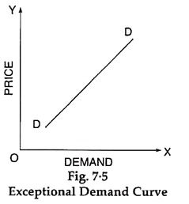](https://www.economicsdiscussion.net/wp-content/uploads/2018/07/clip_image010.png)

1. Ignorance:

Sometimes consumers are fascinated with the high priced goods from the idea of getting a superior quality. However, this may not be always true. Superior/deceptive packing and high price deceive the people. This can be called as ‘Ignorance effect’.

2. Speculative Effect:

When the price of a commodity goes up, people may buy larger quantity than before, if they anticipate or speculate a further rise in its price. On the other hand, when the price falls, people may not react immediately and may still purchase the same quantity as before, waiting for another fall in the price. In both the cases, the law of demand fails to operate. This is known as speculative effect.

3. The Giffen Effect:

A fall in the price of inferior goods (Giffen Goods) tends to reduce its demand and a rise in its price tends to extend its demand. This phenomenon was first observed by SIR ROBERT GIFFEN, popularly known as Giffen effect.

He observed that the working class families of U.K. were compelled to curtail their consumption of meat in order to be able to spend more on bread Mr. Giffen, British economist, observed that rise in the price of bread caused the low paid British workers to buy more bread.

These workers lived mainly on the diet of bread, when price rose, as they had to spend more for a given quantity of bread, they could not buy as much meat as before. Bread still being comparatively cheaper was substituted for meat even at its high price.

4. Fear of Shortage:

People may buy more of a commodity even at higher prices when they fear of a shortage of that commodity in near future. This is contrary to the law of demand. It may happen during times of war and inflation and mostly in the case of goods which fall in the category of necessities of life like sugar, kerosene oil, etc.

5. Prestigious Goods:

This is explained by Prof. Thorsfein Vebler Veblen. If consumers measure the desirability of a good entirely by its price and not by its use, then they buy more of a good at high price and less of a good at low price, Diamond, Jewellery and big cars etc., are such prestigious goods. In their case demand relates to consumers who use them as status symbol.

As their prices go up and become costlier, rich people think it is more prestigious to have them. So they purchase more. On the other hand, when their prices fall sharply, they buy less, as they are no more prestigious goods. This is known as (Veblen effect) or (Demonstration effect).

6. Conspicuous Necessities:

Another exception occurs in use of such commodities as due to their constant use, have become necessities of life. For example, inspite of the fact that the prices of television sets, refrigerators, washing machines, cooking gas, scooters, etc., have been continuously rising, their demand does not show any tendency to fall. More or less same tendency can be observed in case of most of other commodities that can be termed as ‘Upper-Sector Goods’.

7. Bandwagon Effect:

The consumer’s demand for a good may be affected by the tastes & preferences of the social class to which he belongs. If purchasing diamond becomes fashionable, then, as the price of diamond rises, rich people may increase their demand for diamonds in order to show that they are rich.

**Movement along a Demand Curve and Shifts in the Demand Curve (Diagrams):**

1. Change in Quantity Demanded — Movement along a Demand Curve:

Extension and Contraction of Demand- The quantity demanded of a product does not remain constant, but keeps on changing due to various factors. If the quantity demanded changes due to change in price only, it is called expansion and contraction of demand. If price decreases, it results in expansion of demand and if price increases it results in contraction of demand. This situation is shown by movement along the same demand curve.

[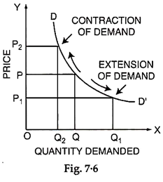](https://www.economicsdiscussion.net/wp-content/uploads/2018/07/clip_image012.png)

In figure 7.6, we have shown expansion and contraction of demand. At price OP, quantity demanded is OQ. If price reduces to OP1, the quantity demanded increase to OQ1. This increase of quantity demanded would be called expansion of demand. If, however, price increases from OP to OP2, then quantity demanded decrease in equality would be called contraction of demand.

2. Change in Demand— Shifts in the Demand Curve:

Increase and Decrease of Demand:

If the change in quantity demanded of a product takes place due to any factor, other than price of the product, then it is called increase or decrease of demand. This phenomenon is shown by a shift in the entire demand curve. For example- if the income of the consumer rises then his entire demand curve shifts to right which shows that consumer’s demand for the product has increased for every given price.

[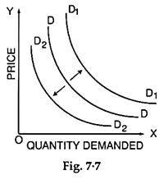](https://www.economicsdiscussion.net/wp-content/uploads/2018/07/clip_image014.png)

In the figure 7.7 we can say if demand increases due to increase in income then demand curve shifts to right from DD to D1D1. If, however, the demand decreases due to fall in income then the demand curve shifts to left from DD to D2D2.

**Inter-Related Demands:**

It has been assumed that demand of a particular commodity is quite independent of demand for other goods. But in actual life, most of the demands are closely inter-related.

From a practical point of view, the inter-related demands can be classified as:

1. Joint Demand

2. Direct Demand and Derived Demand

3. Composite Demand

1. Joint Demand:

When several items are demanded for one particular purpose such demand is known as Joint Demand. Demand for complementary goods is also known as Joint Demand. For example, for fabrication of furniture, the items required are wood, nails, varnish, etc.

Thus, whenever the demand of furniture increases, the demand of wood, nails, etc., also increases. This is called a Joint Demand. Similarly, for the construction of the houses, the demand for bricks, cement, masons, labourers, etc., will constitute a Joint Demand. The Joint Demand for coffee is denoted by the given line diagram (Fig. 7.12).

[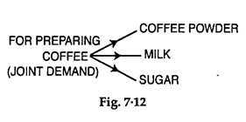](https://www.economicsdiscussion.net/wp-content/uploads/2018/07/clip_image021.png)

2. Direct Demand and Derived Demand:

Whenever several items are required to make a particular commodity, the demand for various commodities is termed as the Derived Demand and demand of ultimate commodity is called as Direct Demand. For example, the demand for building is a direct demand and demands for cement, bricks, sand, timber, etc., are called as derived demands. It is denoted by the given line diagram (Fig. 7.13).

[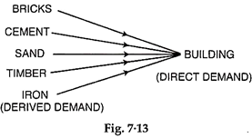](https://www.economicsdiscussion.net/wp-content/uploads/2018/07/clip_image023.png)

3. Composite Demand:

A commodity can be used for several purposes and its demand is directly linked to its sweets various uses such a demand is known as Composite Demand. For example, milk is used for making tea, coffee, butter, cheese, curd, sweets and for direct consumption. The total demand of milk in the market is for all such purposes and it is called composite demand, denoted by the given line diagram (Fig. 7.14).

[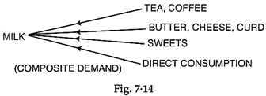](https://www.economicsdiscussion.net/wp-content/uploads/2018/07/clip_image024.png)

**THEORY OF SUPPLY**

It would be inconclusive if we only deal with demand theory without explaining the supply theory as it required in economic theory. Economic theory deals with the behaviour of the business firms which supply in output markets and demand in input markets. Firms engage in production, and we assume that they do so to make profit. Firms makes profits because they are able to sell their goods for more its cost. The amount of revenue made is a function of price it sells its output in the market and how much of it sells.

**Supply in Output Markets**

Thus, *the quantity supplied is the amount of a particular product that a firm would be willing and able to offer for sale at a particular price during a given time period*.

The quantity of a good that a single producer is willing to sell over a particular time period is a function of the price of the good and the producer’s costs of production. To get a producer’s supply schedule and supply curve of a

commodity, certain factors which influence costs of production should be held constant (ceteris paribus).

These are technology, the prices of the inputs necessary to produce the good, and for agricultural commodities, climate and weather conditions

It is reasonable to expect an increase in market price, all things been equal, to lead to an increase in quantity supplied. ***There is linear or positive relationship between the quantity of goods supplied and price***. This statement summed up the law of supply in economics. An increase in market price will lead to an increase in quantity supplied, and a decrease in market price will lead to a decrease in quantity supplied.

**Supply schedule Supply curve**

Supply schedule is a table showing how much of goods firms will sell at different prices. The various price-quantity combinations of a supply schedule can be plotted on a graph to obtain the market supply curve. *Supply curve is a graph describing how much of a goods a firm will sell at different prices*.

**Table 1 Supply Schedule for Ball Pens**

|  |  |
| --- | --- |
| **Price (N)** | **Quantity Supplied** |
| 2.00 | 14 |
| 1.50 | 10 |
| 1.00 | 6 |
| 0.75 | 4 |
| 0.50 | 2 |

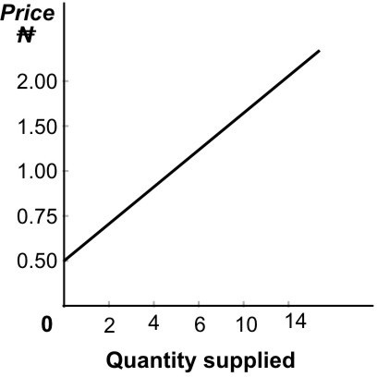

**Figure1: Supply curve for ball pens, it shows supply curve shows that the higher ball pens prices induces to supply greater quantities**

The positive slope of the supply curve (i.e. its upward-to-the right inclination) reflects the fact that higher prices must be paid to producers to cover rising marginal, or extra, costs and thus induce them to supply greater quantities of the commodity.

The various points on the supply curve show price-quantity relationships. For instance, at the price of N.50 per pen, the quantity supplied is 2. The trend is repeated for all the various quantities of ball pen and prices. This direct relationship between price and quantity is reflected in the positive slope of the supply curve Supply curve above also shows the minimum price that producers must receive to cover their increasing marginal costs and supply each quantity of the commodity.

**The difference between shift of supply curve and the movement along a supply curve**

The supply curve is derived by holding everything constant except price. So, the movement along a supply curve is caused the change in quantity supplied brought by a change in price. The change that takes place in a supply curve corresponding to a new relationship between quantity supplied of a goods and the price of that goods. The shift is brought about by a change in the original conditions. Increases in input prices may also cause supply curves to shift. Change in prices of goods or services lead to change in quantity supplied- movement along a supply curve. *Change in costs, input prices, technology, or prices of related goods and services leads to change in supply – shift of a supply curve.*

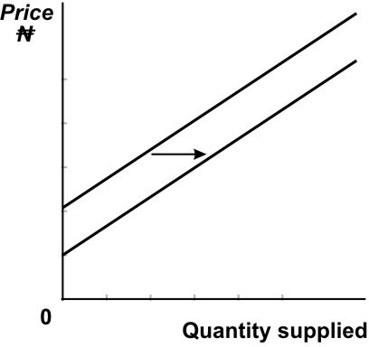

**Figure 2.2**

**Determinants of Supply**

Price has been so far discussed as one of the factors that affect the quantity of output supplied. Other factors that affect the supply include the cost of producing the product and the prices of related goods.

**Cost of Production**: the difference between costs and revenues is called profit. Successful firms make profits because they are able to sell their goods for more than it costs to produce them. So, among other factors that determine size of profit to be made cost and price of inputs is one of them. But the way of production to maximize profit is to minimize cost of production. The increase in input prices raise costs of production and are likely to reduce supply.

**Prices of Other Associated Goods:** Firms always react to changes in the prices of related products in the market. For example, if a plant can be used for either pen or pencil production, an increase in pen prices may cause individual entrepreneur to make use of time allotted to the production of pencil, thereby producing more of pens than pencils. Increase in price of mutton producer/entrepreneur may respond by raising more sheep.

**Market Supply**

Market supply is determined in the same fashion as market demand. It is simply the sum of all that is supplied each period by all producers of a single product. The market supply curve is thus the simple addition of the individual supply curves of all the firms in a particular market – that is, the sum of all the individual quantities supplied at each price. The market or combined supply of

a commodity gives the alternative amounts of the commodity supplied per time period at various alternative prices by all the producers of this commodity in the market. The market supply of a commodity depends on all the factors that determine the individual producer’s supply and, furthermore, on the number of producers of the commodity in the market

The position and shape of the market supply curve depend on the positions and shapes of the individual firms’ supply curves from which it is derived. They as well as depend on the number of firms that produce in that market. If firms that produce for a particular market are earning high profits, other firms may be tempted to go into that line of business. When new firms enter into an industry, the supply curve shifts to the right. But when firms go out of business, or exit the market, the supply curve shifts to the left.

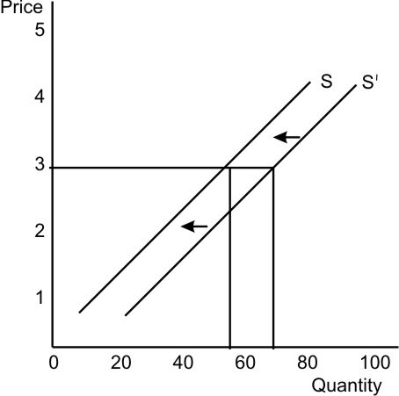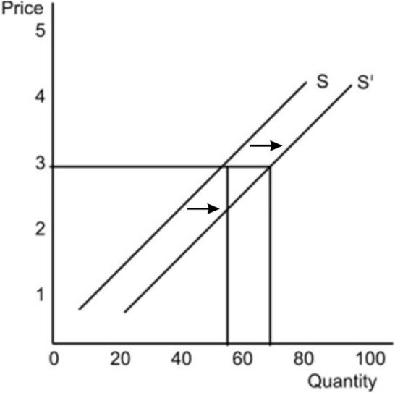

#### Figure 2.3 Figure 2.4

#### Market supply curves shift leftward Market supply curves shift rightward